***GESTURE CONTROLLED ROBOT USING RASPBERRY PI 3 MODEL B+***

**SECOND YEAR PROJECT REPORT**

**DEBANIK ROY**

**SESSION 2017 - 2021**



SUPERVISED BY

DR. ANKUSH GHOSH

DEPARTMENT OF ROBOTICS AT THE NEOTIA UNIVERSITY(MAY 2019)

Dedicated to youtubers and my respected teachers for for their guidance and prayers in every possible manner.

**ACKNOWLEDGEMENT**

We would like to acknowledge our yotubers and all Teachers, who supported us both morally and technically, especially pyimagesearch helped me at every step in the making of my project.

**ABSTRACT**

Gesture Controlled Robot is a robot which can be controlled by simple gestures. The user just needs to wear a camera device . The sensor will record the movement of hand in a specific direction which will result in the movement of the robot in the respective direction. The robot and the Gesture device are connected wirelessly via radio waves. The wireless communication enables the user to interact with the robot in a more friendly way.

INTRODUCTION Recently, strong efforts have been carried out to develop intelligent and natural interfaces

between users and computer based systems based on human gestures. Gestures provide an

intuitive interface to both human and computer. Thus, such gesture-based interfaces can not only

substitute the common interface devices, but can also be exploited to extend their functionality.

**1.1 ROBOT**

A robot is usually an electro-mechanical machine that can perform tasks automatically. Some

robots require some degree of guidance, which may be done using a remote control or with a

computer interface. Robots can be autonomous, semi-autonomous or remotely controlled. Robots

have evolved so much and are capable of mimicking humans that they seem to have a mind of

their own.

**1.2 HUMAN MACHINE INTERACTION**

An important aspect of a successful robotic system is the Human-Machine interaction. In the early years the only way to communicate with a robot was to program which required extensive hard work. With the development in science and robotics, gesture based recognition came into life. Gestures originate from any bodily motion or state but commonly originate from the face or hand. Gesture recognition can be considered as a way for computer to understand human body language. This has minimized the need for text interfaces and GUIs (Graphical User Interface).

**1.3 GESTURE**

A gesture is an action that has to be seen by someone else and has to convey some piece of information. Gesture is usually considered as a movement of part of the body, esp. a hand or the head, to express an idea or meaning.

**1.4 MOTIVATION FOR PROJECT**

Our motivation to work on this project came from a disabled person who was driving his wheel chair by hand with quite a lot of difficulty. So we wanted to make a device which would help such people drive their chairs without even having the need to touch the wheels of their chairs.

**1.5 OBJECTIVE OF PROJECT**

Our objective is to make this device simple as well as cheap so that it could be mass produced and can be used for a number of purposes

**GESTURE CONTROLLED ROBOT**

Gesture recognition technologies are much younger in the world of today. At this time there is much active research in the field and little in the way of publicly available implementations. Several approaches have been developed for sensing gestures and controlling robots. Glove based technique is a well-known means of recognizing hand gestures. It utilizes a sensor attached to a glove that directly measures hand movements. A Gesture Controlled robot is a kind of robot which can be controlled by hand gestures and not the old fashioned way by using buttons. The user just needs to wear a small transmitting device on his hand which includes a sensor which is an accelerometer in our case. Movement of the hand in a specific direction will transmit a command to the robot which will then move in a specific direction. The transmitting device includes a Comparator IC for assigning proper levels to the input voltages from the accelerometer and an Encoder IC which is used to encode the four bit data and then it will be transmitted by an RF Transmitter module.

At the receiving end an RF Receiver module will receive the encoded data and decode it by using a decoder IC. This data is then processed by a microcontroller and passed onto a motor driver to rotate the motors in a special configuration to make the robot move in the same direction as that of the hand.

**2.2 APPLICATIONS**

• Through the use of gesture recognition, remote control with the wave of a hand of various devices is possible.

• Gesture controlling is very helpful for handicapped and physically disabled people to achieve certain tasks, such as driving a vehicle.

• Gestures can be used to control interactions for entertainment purposes such as gaming to make the game player's experience more interactive or immersive.

•Gesture controlling Robotic ARM which has application on nuclear science.

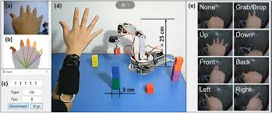

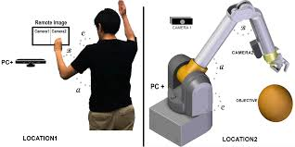

**Component:**

1. Pi Camera

2. raspberry pi 3 model b+

3. 2 pic Dc Motor

4. few jumper cable

5. 5 volt adapter

6. bot

**1. Pi Camera:**

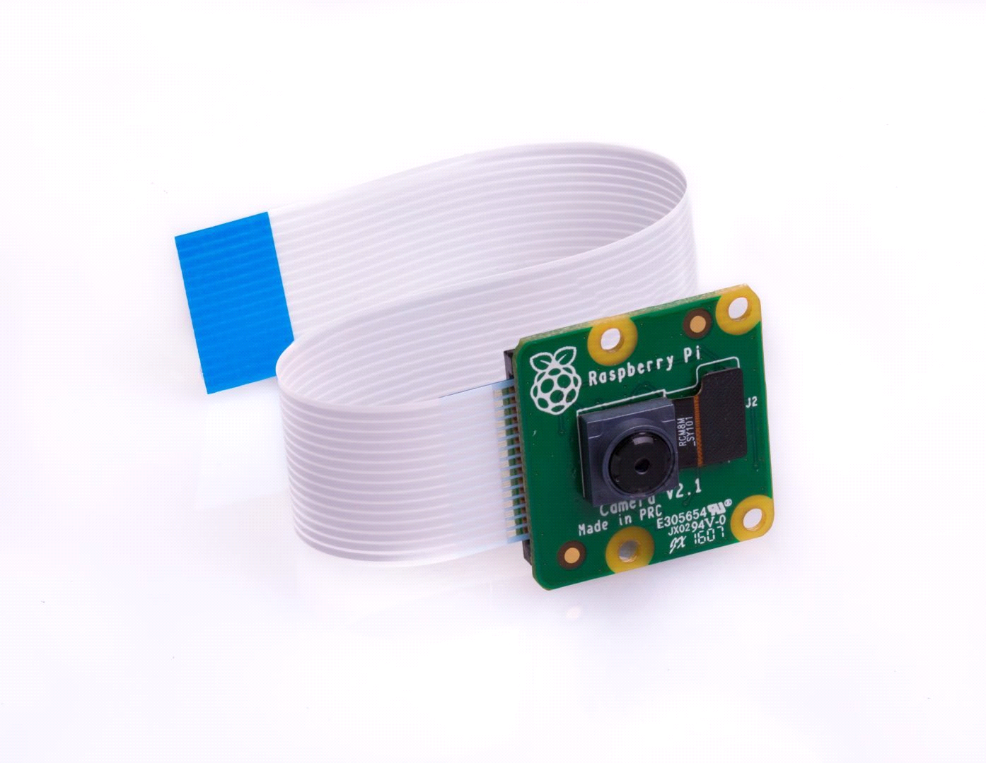

The camera consists of a small (25mm by 20mm by 9mm) circuit board, which connects to the Raspberry Pi's Camera Serial Interface (CSI) bus connector via a flexible ribbon cable. The camera's image sensor has a native resolution of five megapixels and has a fixed focus lens.

**2. raspberry pi 3 model b+:**

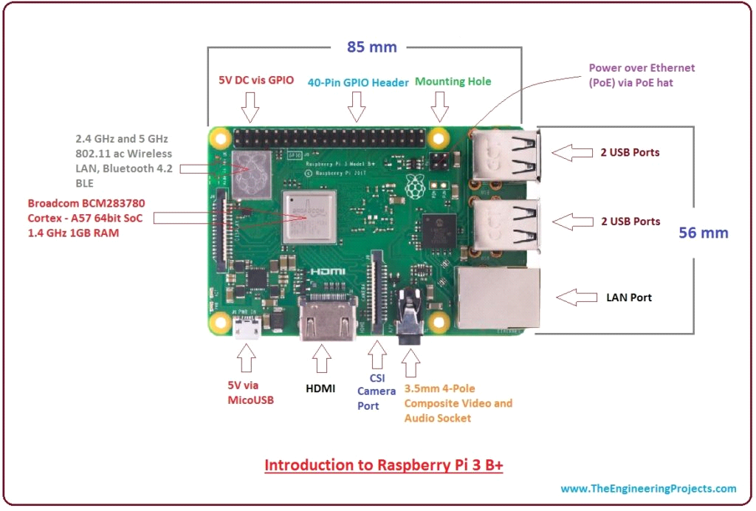

Raspberry Pi 3 B+ was introduced by Raspberry Pi foundation on 14th March 2018. It is an advanced version of Raspberry Pi 3 B model that was introduced in 2016.

It is a tiny computer board that comes with CPU, GPU, USB ports, I/O pins, WiFi, Bluetooth, USB and network boot and is capable of doing some functions like a regular computer.

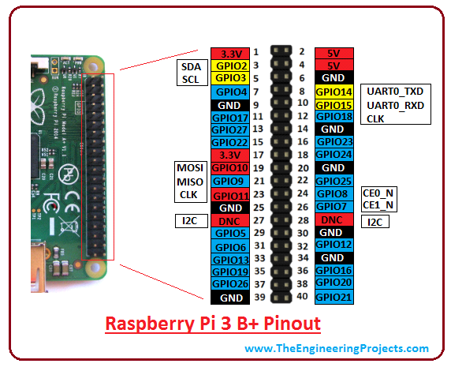

**CPU:** The CPU is a brain of this tiny computer that helps in carrying out a number of instruction based on the mathematical and logical formulas. It comes with a capacity of 64 bit.

**Clock Speed and RAM:** It comes with a clock speed of 1.4 GHz Broadcom BCM2837B0 that contains quad-core ARM Cortex-A53 and RAM memory is around 1GB (identical to the previous version)

**GPU:** It stands for graphics processing unit, used for carrying out image calculation. Broadcom video core cable is added in the device that is mainly used for playing video games.

**USB Ports:** Two more USB ports are introduced in this new version, setting you free from the hassle of using an external USB hub when you aim to join a number of peripherals with the device.

**MicroUSB Power Source Connector:** This connector is used for providing 5V power to the board. It draws 170 to 200mA more power than B model.

**HDMI and Composite Connection:** Both audio output socket and video composite now reside in a single 4-pole 3.5mm socket which resides near HDMI. And the power connector is also repositioned in new B+ model and lives next to HDMI socket. All the power and audio video composite socket are now placed on the one side of the PCB, giving it a clean and precise look.

**USB Hard Drive:** The USB hard drive is available on the board that is used to boot the device. It is identical to the hard drive of regular computer where windows is used to boot the hard drive of the computer.

**PoE:** B+ model comes with a facility of Power over Ethernet (PoE); a new feature added in this device which allows the necessary electrical current using data cables.

**Other Changes:** The B+ version comes with little improvement in the features and poses slightly different layout in terms of location of the components. The SD memory slot is replaced by a micro SD memory card slot (works similar to the previous version). The status LEDs now only contain red and green color and relocated to the opposite end of the PCB.

**3. Dc Motor :**

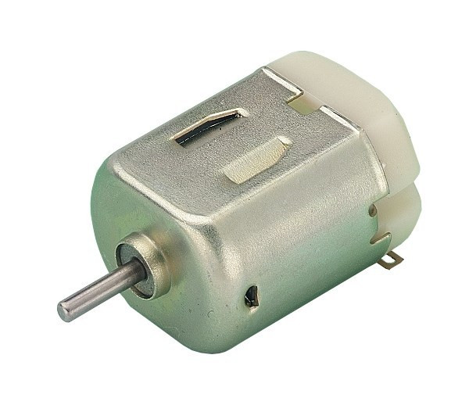

A DC motor is any of a class of rotary electrical machines that converts direct current electrical energy into mechanical energy. The most common types rely on the forces produced by magnetic fields. Nearly all types of DC motors have some internal mechanism, either electromechanical or electronic, to periodically change the direction of current flow in part of the motor.

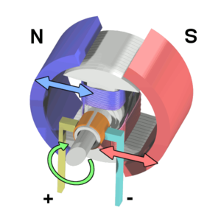

**working process:**

Step 1:Load raspbian os on a micro sd card and insert into raspberry pi3 model B+.

Step 2:

Open Laptop’s Network sharing centre and share nework connection.

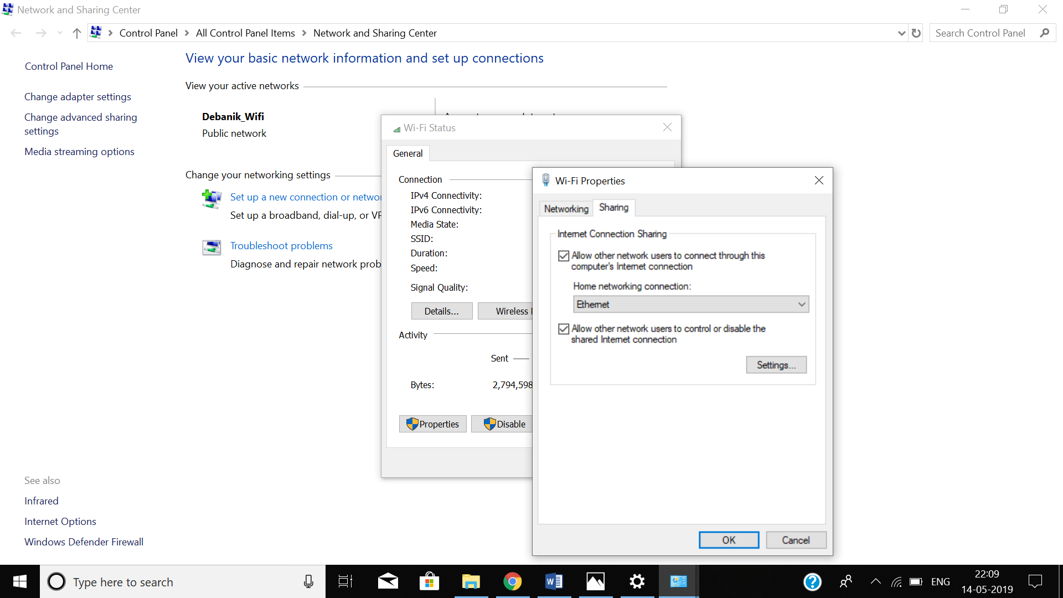

Step 3:

Make sure SSH server is enabled otherwise enable it manually.

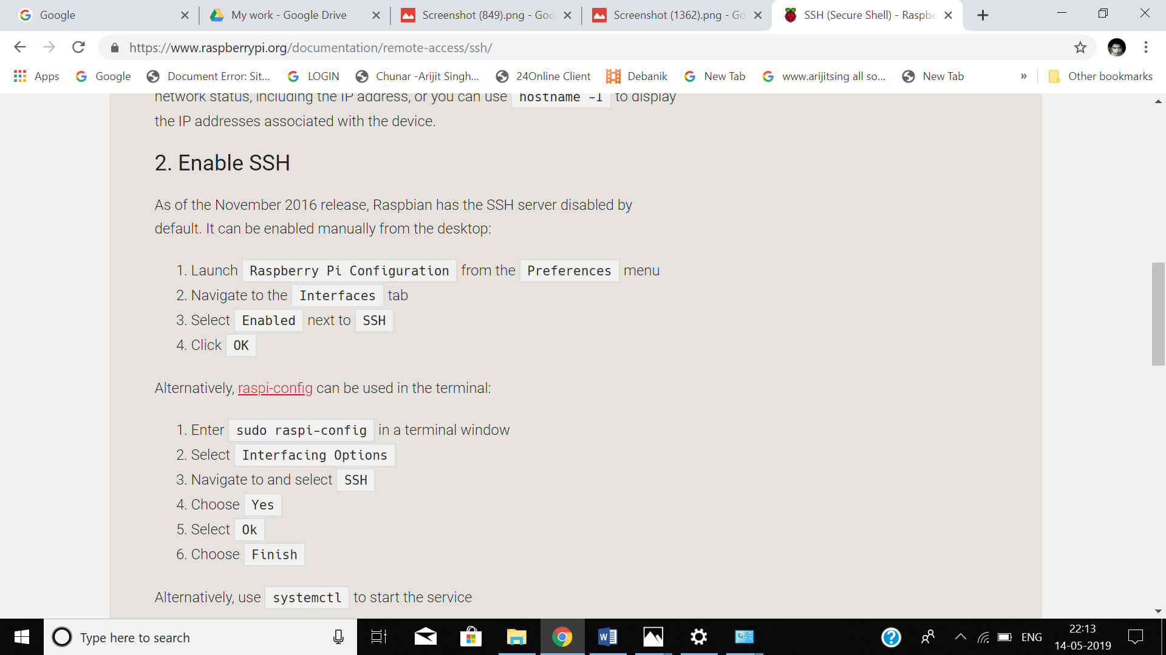

Step 4:

Power on raspberry pi and connect a LAN cable with Laptop and pi.

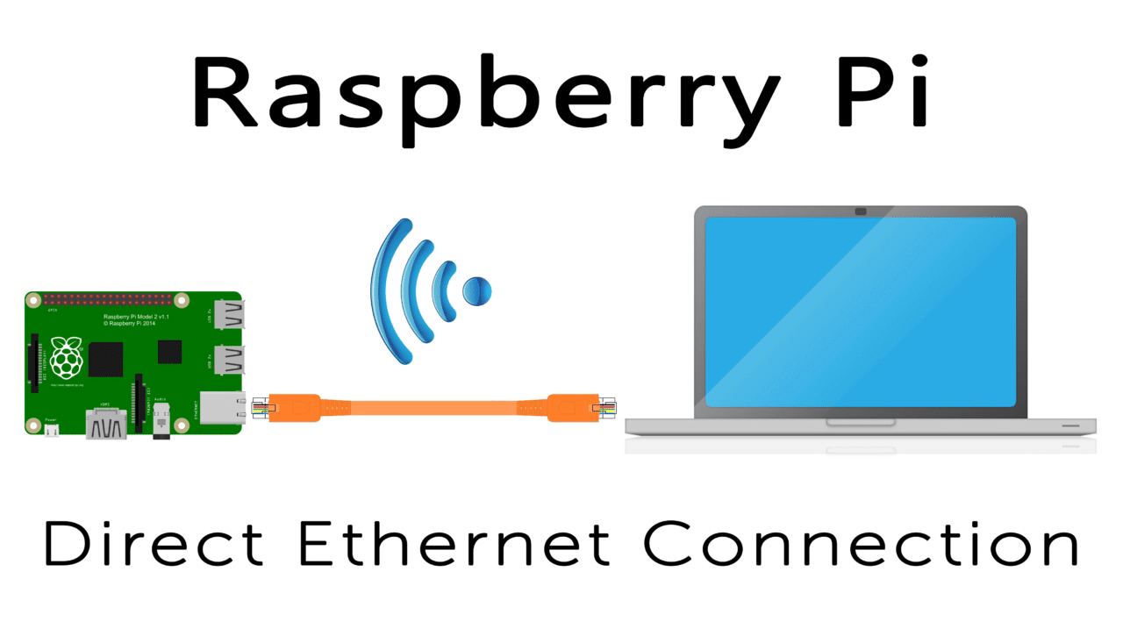

Step 5:

Open Advance Ip scanner and copy the detected Ip address for raspberry pi.

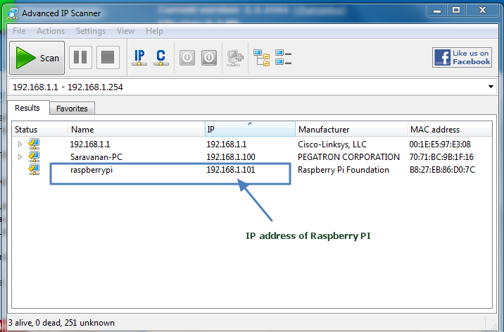

Step 6:

Open MobaXterm and pest detected Ip address.

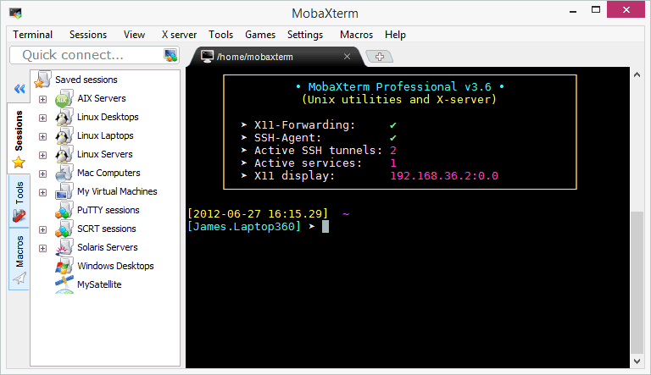

Step 7:

Default user name is = pi

Default password is = raspberry

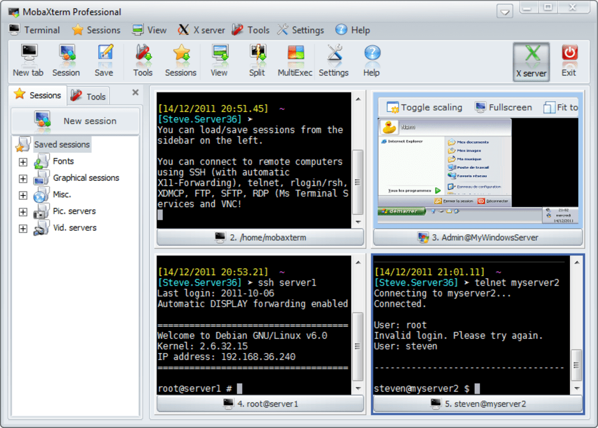

Step8:

Update and upgrade your raspberry pi

>>sudo apt-get update

>>sudo apt-get upgrade

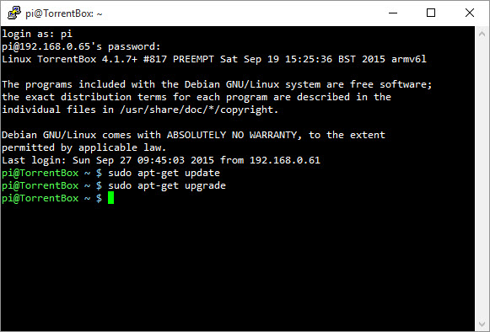

step9:

Install VNC server on raspberry pi, laptop and Phone for remote server control.

>>sudo apt-get install tightvncserver

and activate it.

>> tightvncserver

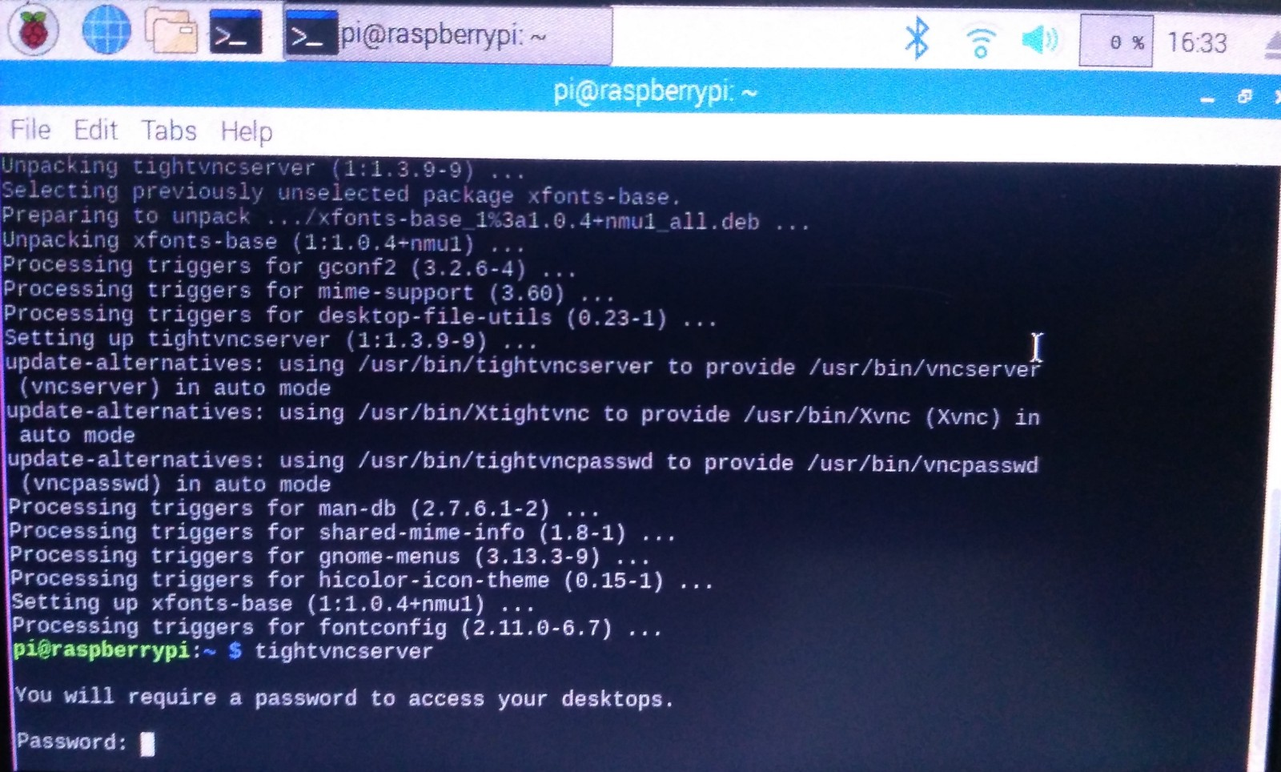

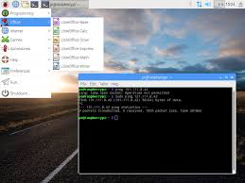

Step10:

>> sudo raspi-config

Open Networking option and enable wifi and connect it via phone.

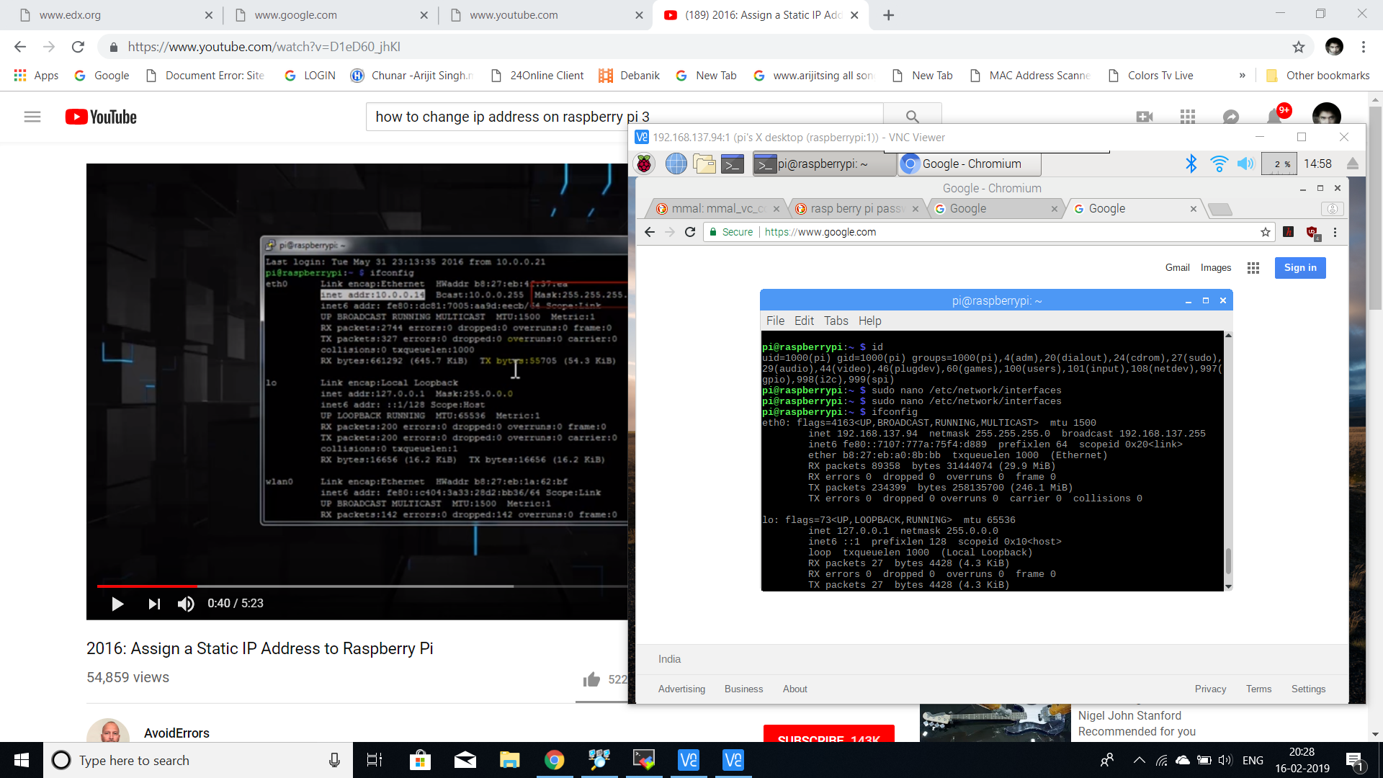

Step11:

>>ifconfig

Copy your wlan0 ip address

>>netstat –nr

Copy your static router ip address

>>sudo nano /etc/dhcpcd.conf

On the nano editor

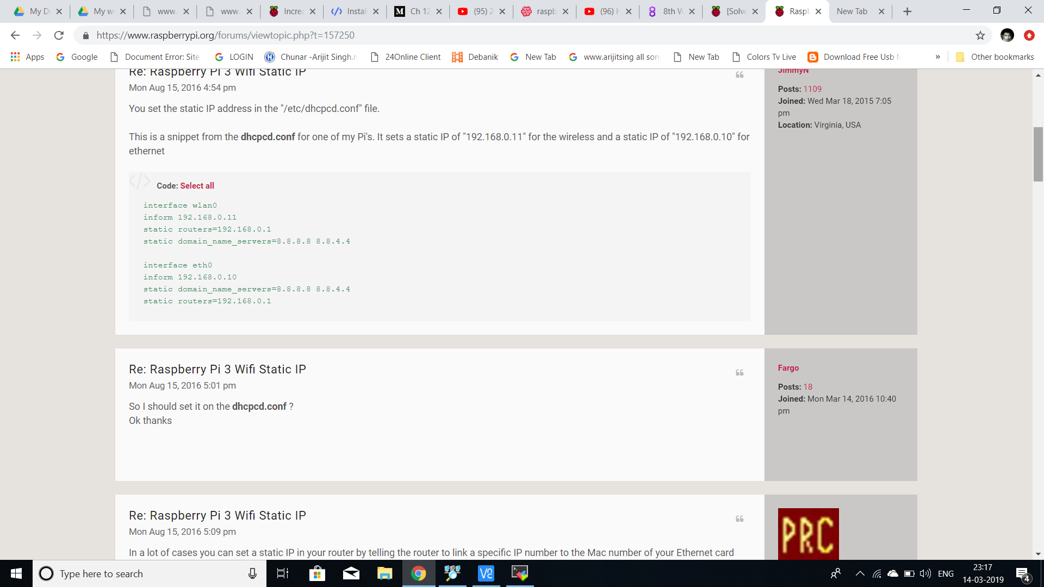

Step12:

Disconnect your LAN connection and see Raspberry pi is now connected via your phone. Laptop has connected via same network and now open MobaXterm and type static ip and it’s boom!!! Working working working .

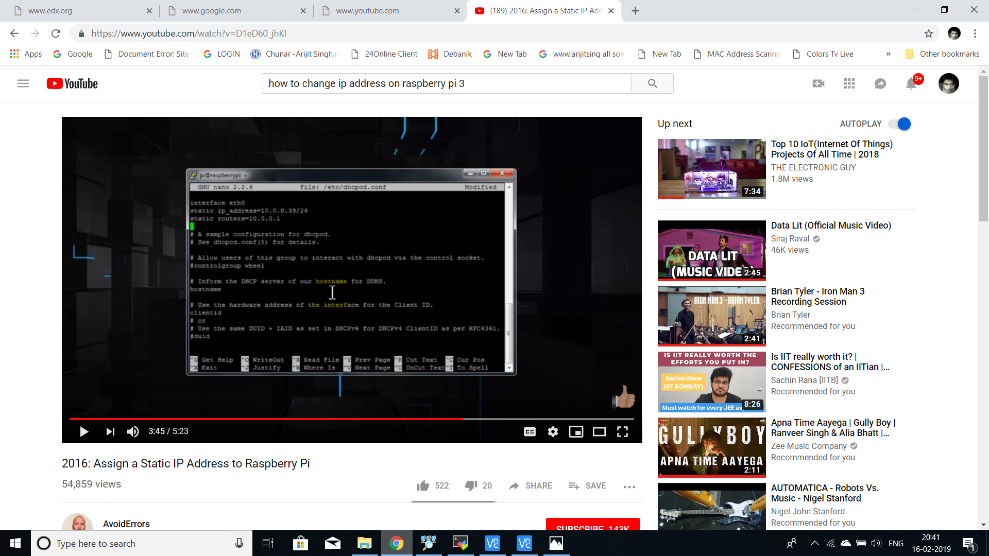

Step13:

Install open cv

Click here: <https://www.alatortsev.com/2018/11/21/installing-opencv-4-0-on-raspberry-pi-3-b/>

Step14:

>> sudo raspi-config

Open interfacing divice and enable pi camera

Step15:

Make HARDWARE MODEL and connect it with Raspberry pi via GPIO poart

For me

GPIO11-pin23 -> en1 (H-bridge)

GPIO9-pin21 -> in1 (H-bridge)

GPIO10-pin19 -> in2 (H-bridge)

GPIO23-pin16 -> en2 (H-bridge)

GPIO24-pin18 -> in3 (H-bridge)

GPIO25-pin22 -> in4 (H-bridge)

Step16:

Programming:

Click here:

<https://drive.google.com/open?id=1Sh5yVkCqfjHLWJhdc5WSZIGe599BEuJc>

other raspberry pi3 model B+ Linux CMD:

echo>G:\ssh

ssh

pi

raspberry

sudo apt-get install tightvncserver

raspberrypi:1.log

sudo raspi-config

Camera=

PHOTO

raspistill

raspistill -o image.jpg

VIDEOS

raspivid

raspivid -o testvideo.h264 -t 10000

1.pwd

2.cd /home #change folder

3.~cd #Back to initial posi

4.ls #list the contents of a directory

5. mndir example

6.cd example/

7.nano test.py

8.python

9.quit() # Stop Python

10. wget http address

11.sudo apt-get install git

12.rm name #To remove some thing

13.rm -r folder name/

14.ls -a # All hidden content shown

15.ls -al

16.ls --all

17.ls --help

18.sudo apt-get update

19.sudo apt-get upgrade # install new package

20.sudo shutdown -h now #shut down

21. sudo shutdown -r now # restart

22.nano cameraexample.py

23.sudo apt-get install python-picamera

24.sudo apt-get install python-rpi.gpio

25.^ d #back to initial position

26. unzip abc.zip

27.nano name.py

28.python3 name.py

29.sudo nano /etc/dphys-swapfile

30.CONF_SWAPSIZE=100

31.source ~/.profile

32. sudo pip3 install imutils

**CONCLUSION, LIMITATIONS AND FUTURE WORK**

**CONCLUSION**

We achieved our objective without any hurdles i.e. the control of a robot using gestures. The

robot is showing proper responses whenever we move our hand. Different Hand gestures to

make the robot move in specific directions are as follow:

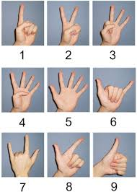

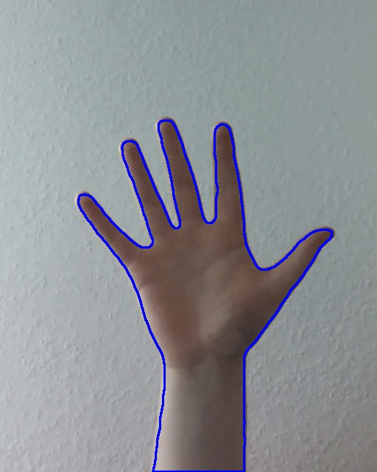

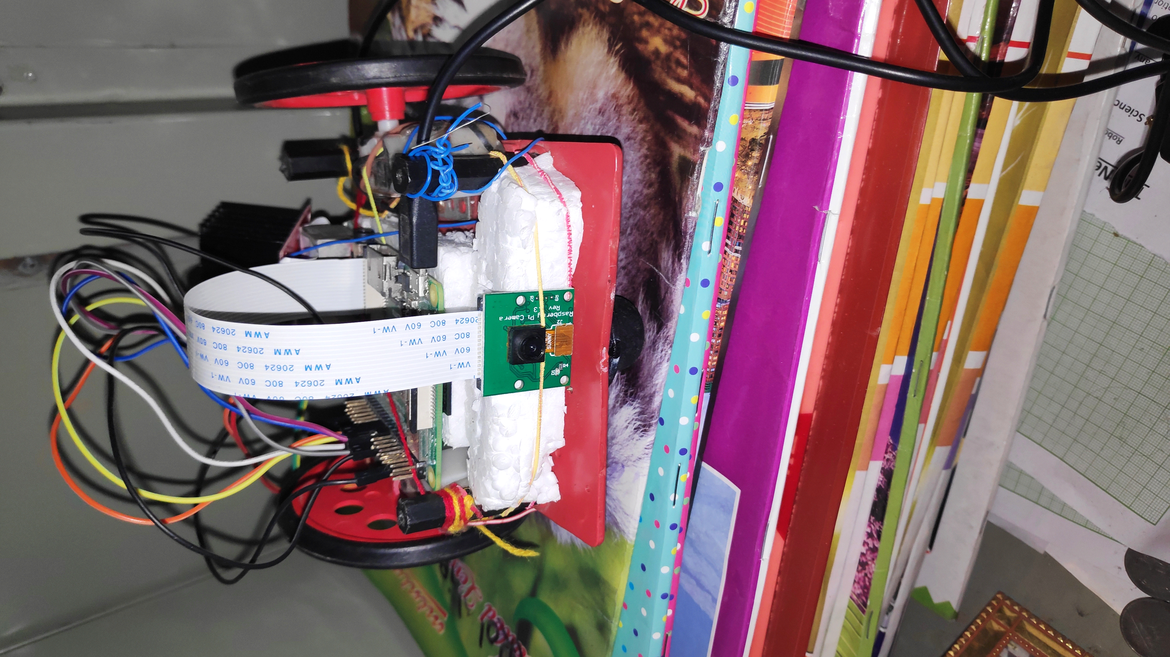

**THANK YOU**